Промежуточная аттестация по английскому языку для 6 класса.

**Задание 1. Послушай и выбери правильный ответ.**

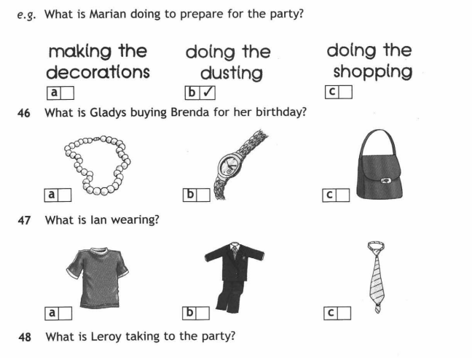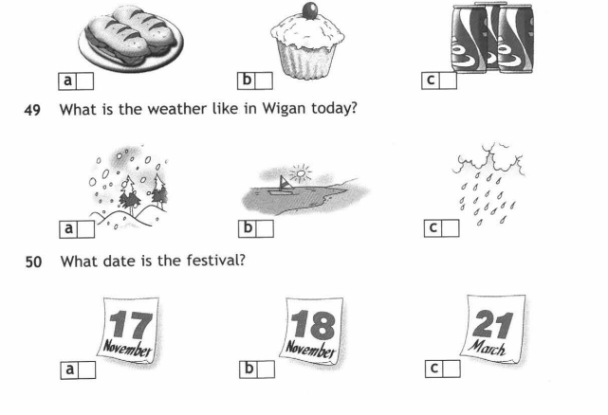

**Задание 2. Прочитай и выбери правильный ответ.**

|  |  |
| --- | --- |
| 1. Brendan has got a brother.  **A** double **B** twice **C** twin | 6. We met ten years............................  **A** gone **B** ago **C** past |
| 2. June is the month of the year.  **A** sixth **B** six **C** sixteen | 7. We had a nice picnic in the .................  **A** restaurant **B** stadium **C** park |
| 3. Do you your teeth every day?  **A** wash **B** brush **C** do | 8. Pedro is from Barcelona; he is.......................  **A** Spanish **B** S pain **C** Spaniard |
| 4. On Christmas Day, we all gifts.  **A**  transfer **B** exchange **C** change | 9. “What’s the date today?” “I think it’s...........”  **A** 25th July **B** Tuesday **C** 1999 |
| 5. Chess and backgammon are both ............ games.  **A** table **B** bored **C** board | 10. ................. your home address?  **A** What’s **B** Where’s **C** How’s |

**Задание 3. Напиши форму Прошедшего Простого Времени глаголов.**

|  |  |  |  |  |  |
| --- | --- | --- | --- | --- | --- |
| **1** | drink — | ........................................... | **6** | come — | ........................................... |
| **2** | see — | ........................................... | **7** | leave — | ........................................... |
| **3** | go — | ........................................... | **8** | give — | ........................................... |
| **4** | find — | ........................................... | **9** | make — | ........................................... |
| **5** | hear — | ........................................... | **10** | be — | ........................................... |

**Задание 4. Раскрой скобки, напиши предложения в Прошедшем Простом Времени.**

|  |  |  |  |
| --- | --- | --- | --- |
| **1** | Paul  **(find)** a wallet on the bus yesterday. | **6** | ..................... **(we / meet)** on holiday last summer? |
| **2** | My brother **(spend)** €120 on CDs last weekend. | **7** | I ..................... **(not / hear)** a lot about you. |
| **3** | We **(decide)** to stay in and watch a film last night. | **8** | ....................... (**Albert Einstein / die)** in 1955? |
| **4** | I **(knock)** at the door but no one was in. | **9** | I........................................ **(read)** an interesting article about dogs this morning. |
| **5** | He ....................................**(say)** hello to me but I don't know who he is. | **10** | He was so happy that he ....................................  **(jump)** up and down. |

**Задание 5. Прочитай тексты (1 – 5) и подбери к каждому из них заголовок (A – F), один заголовок является лишним.**

**A** Transport          **B** Tourism          **C** Sport

**D** Food                 **E** Home              **F** Leisure

**1.** Mexico City is one of the world’s largest cities. It has beautiful old buildings, green parks, museums and exciting nightlife. It is a great place to visit. Nine million people visit it every year.

**2.** Many people live in beautiful houses with gardens. Others live in blocks of flats near the city center.

**3.** Mexico City is a difficult city to drive in because of the heavy traffic. The city’s fantastic metro has 11 lines and it is very cheap. There are hundreds of buses, trolleybuses and minibuses, too.

**4.** In their free time Mexicans do shopping at colorful street markets. They also enjoy going to the cinema and theatre. They have street parties.

**5.** The people of Mexico City are very friendly. The food is excellent too! The restaurants served tasty food like tortillas and beans.